

CEF 440: INTERNET PROGRAMMING (j2ee)

AND MOBILE PROGRAMMING

**PROJECT: *DESIGN AND IMPLEMENTATION OF A MARKET MANAGEMENT SYTEM***

**TASK 2: REQUIREMENT GATHERING**

GROUP MEMBERS

|  |  |
| --- | --- |
| **NAME** | **MATRICULE** |
| GAMUAH PADJINOU RYANE JOY | FE20A044 |
| NDALEGH NOELA LUM MBAH | FE20A070 |
| FORMASIT CHIJOH FOKUNANG | FE20A041 |
| RACHEAL NKONGHO TAFONGOH | FE20A100 |
| MOSONGO ADINA SAKWE NANGERI | FE20A066 |

**COURSE INSTRUCTOR:**

DR. NKEMENI VALERY

Thursday, 06th April 2023.

**TABLE OF CONTENTS**

1. *INTRODUCTION*
   1. Problem Statement
   2. Objective
   3. Proposed solution
2. *PROJECT DESCRIPTION*
   1. Purpose
   2. Brief Outline
   3. Application uses
3. *PROJECT REQUIREMENTS*

3.1) Functional Requirements

3.2) Non-functional Requirements

3.3) Methods of Verification/Validation

1. *PRODUCT DESIGN AND IMPLEMENTATION*

4.1) Application Type

4.2) UML Diagrams

4.2.1) Use Case Diagram

4.2.2) Class Diagram

4.2.3) Activity Diagram

4.2.4) Sequence Diagram

4.3) Technology

4.3.1) Programming Languages

4.3.2) Frameworks

1. *CONCLUSION*

**INTRODUCTION:**

**Problem Statement**

There are generally many vendors of a variety of products in different places. It is frustrating, tiring and time consuming when the buyer is uncertain of the location of a vendor who sells the items he is looking for, and at favorable prices, and has to search going from one shop to another. It is also disadvantageous to the vendor as he may lose potential customers daily because they are not aware of his location, the goods he sells, as well as their prices.

It is much easier to go to the market with a specific shop in mind, and an already set budget.

**Objective**

With the draw backs listed in the problem statement above, it is clear that the objective of this project is to enable sellers, market their products more efficiently, and help buyers locate shops in the market based on their specific needs (product - price).

**Proposed solution**

With the stated objectives in mind, the following are proposals to achieving them:

* A mobile application can be developed to help vendors advertise their products, giving the product specifications (price, state, availability) and their location.
* The buyers will be able to search for a product in the market, choose the shop with the most suitable price for her and get the precise location of the shop in the market.

**PROJECT DESCRIPTION:**

This application aims at improving marketing strategies for vendors and increasing the ease of grocery shopping for buyers, in a typical market demographic. It is used by both customers and sellers where the customers can review the prices of certain items in the market, their availability, and location, whereas the sellers can display their products, their prices and location in the market.

The application helps both buyers and sellers in the following ways:

- The buyers are aware of the availability, prices, and location of their desired item before they visit the market

- The buyers can decide on the best location to purchase goods from thanks to reviews and ratings of shops/boutiques

- The sellers can attract the right customers to their shades

- The sellers gain more exposure and possess a better and more efficient platform to advertise their products

**PROJECT REQUIREMENTS:**

In order to successfully develop and deploy such an application so that it functions correctly, it is important to gather, outline and study the system requirements to be satisfied.

**Functional Requirements**

* Customers should be able to view the list of available items in the market
* Customers should be able to see the average prices of goods
* Customers should be able to view locations (shops) where an item is found in the market
* Customers should be able to view list of items for sale in a shop
* Customers should be able to view status of commodities in a shop (available, sold out)
* Customers should be able to search for shops and their location in the market
* Customers should be able to rate a shop for credibility
* Vendors should be able to advertise their products on the application, labelling with their true status and prices
* Vendors should be able to signal their location in the market to potential buyers
* Vendors should be notified of sold out products to change their status after external restock

**Non-functional Requirements**

* **Performance**: The system should function correctly and quickly all the time, even during peak market hours when there is high traffic on the system so as to efficiently aid in decision making
* **Security**: Customer or vendor data should be gravely protected and locked against unauthorized access.
* **Usability**: The system should be generally easy to use/maneuver for the general population
* **Integrity:** The system should ensure that only the correct information as provided by the user should be displayed to the public and stay that way until changed.
* **Scalability:** The application should be able to accommodate as many users without reducing performance.
* **Compatibility:** The application should be hybrid and compatible with all operating system types.
* **Hardware:** The hardware devices which could be used to interact with the system should be stated before-hand. Examples include mobile phones, laptop and desktop devices.

**Methods of Verification/Validation**

It is important to verify and validate the software requirements for an application and this is no exception. Measures were taken to verify and validate the requirements gathered so far so ensure that the right product will be built and in the right way.

This was accomplished by interviewing users (buyers, vendors), asking them the following questions:

**Vendors:**

* Have you heard of a market management software?
* Would you like to register your shop in such system? If no, why?
* Would you like to share your shop location online? If no, why?
* Would you like for customers to rate the service of your shop and leave reviews? If no, why?
* Do you trust such an application can greatly improve your business? If no, why?
* Is there anything you think the system can also offer to improve the performance of your business?

**Buyers:**

* Have you heard of a market management software?
* Do you like the idea of using such an application? If no, why?
* Do you appreciate the idea of rating a shop/boutique or leaving reviews about their service? If no, why?

The feedback gathered from the mass interviews, and re-viewing the project specification document verified the initial requirements gathered and show that we are building the right product and also validated these requirements ensuring that we are building the product the right way. This also led to the generation of new functional requirements which were added above.

**PRODUCT DESIGN AND IMPLEMENTATION:**

**Application Type**

The application will be a hybrid mobile application for the following reasons:

* Hybrid applications offer the advantage of code reusability of the web application reducing time of development and cost.
* It is written in web programming languages, making finding resources to build it easier.
* The application can use the devices internal features as they have a native app shell, which helps improve on user experience.

**UML Diagrams**

It is indispensable that the different UML diagrams describing the flow of the product be designed. They provide a template to understand and follow, from which the product proper can be developed.

**Use Case Diagram**

It presents a graphical depiction of user’s possible interactions with the system. It shows the various use cases and the different users the system has showing their interactions. It describes the high-level functions and scope of the system, but not how the system operates internally.

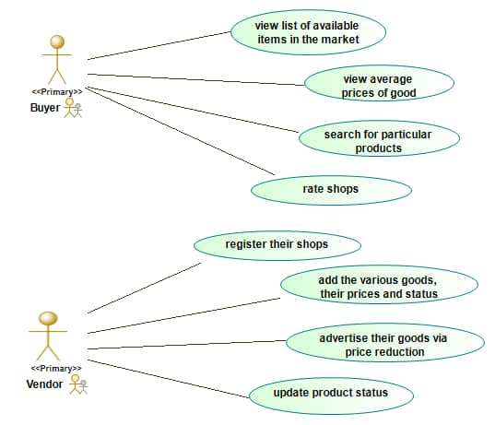

**Class Diagram**

This is the blueprint of the system. It models the objects that make up the system, displays the relationships between them, and describes what those objects do and the services that they provide. It is basically a graphical representation of the static view of the system and represents the different aspects of the application.

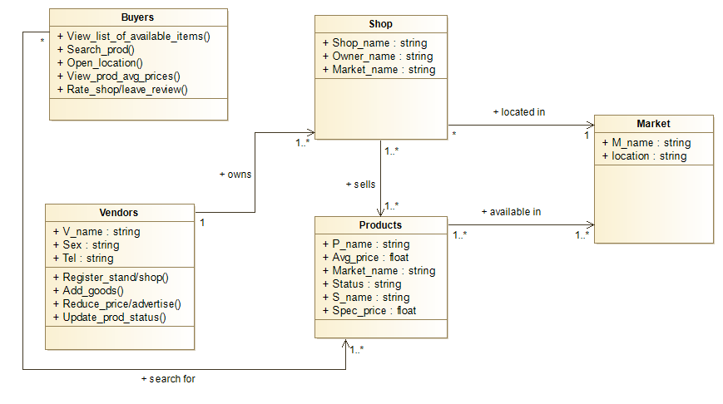

**Activity Diagram**

It visually presents a series of actions or flow of control (from one activity to another) in the system. It describes the steps in the use case diagram. It depicts the workflow from start point to finish point.

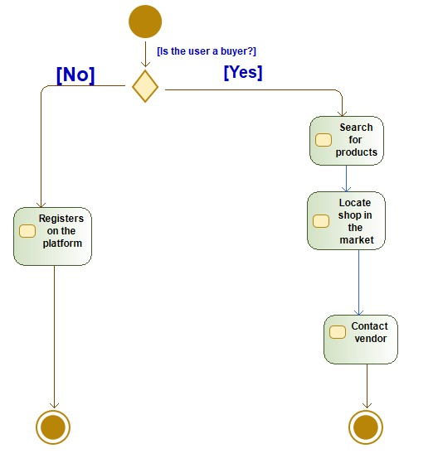

**Sequence Diagram**

These diagrams describe how - and in what order – a group of objects work together. They are important in aiding to understand the system requirements or document a process. They show the process interactions arranged in time sequence.

Represented below are major sequence diagrams which cover the scope of the project.

**Add Product Sequence Diagram**

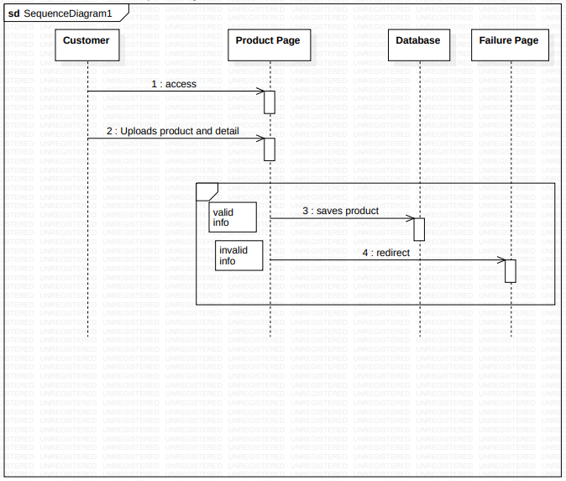

**Search Product Design**

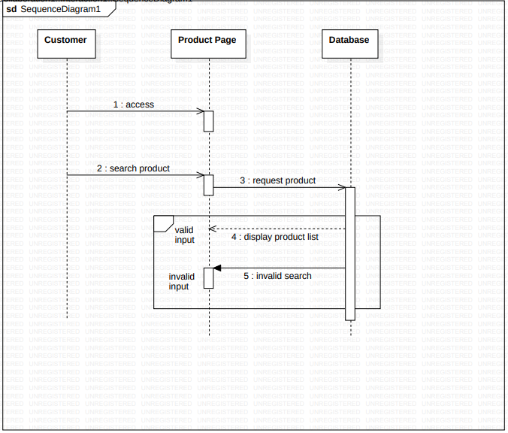

**TECHNOLOGY**

This refers to the software packages, languages and systems used by the industry for software analysis, development and security.

**Programming languages**/**Frameworks**

Based on the type of application we are developing, the most suitable programming languages are Javascript, php, python because of their specificities. Suitable frameworks to use include React Native (Mobile View) and Laravel (Web View).

**CONCLUSION:**

In conclusion, this application will help save buyers time in searching for products and also in turn aid the sellers in increasing sales as they gain exposure where more clients get to discover their store.